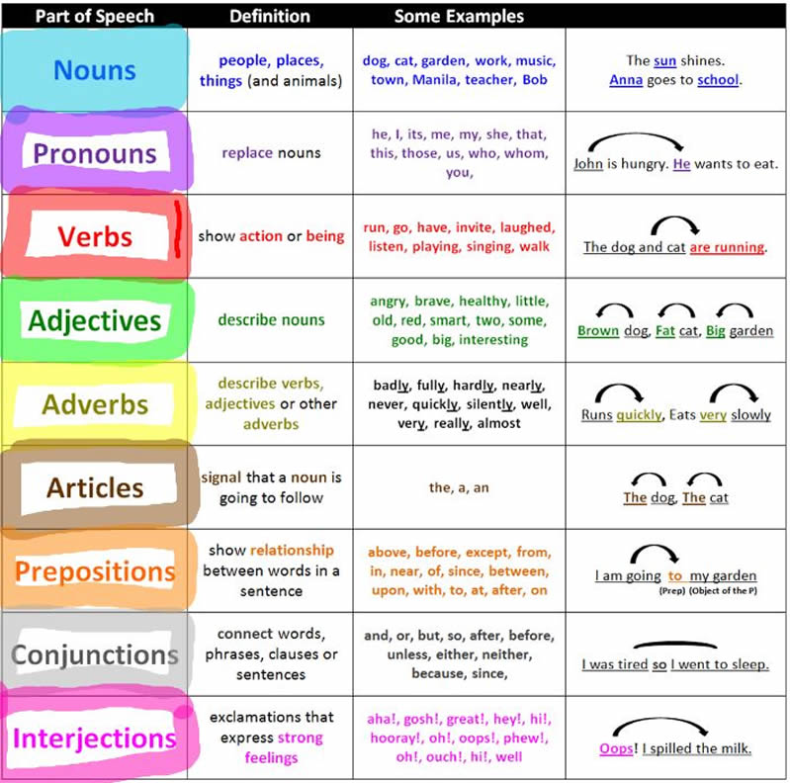

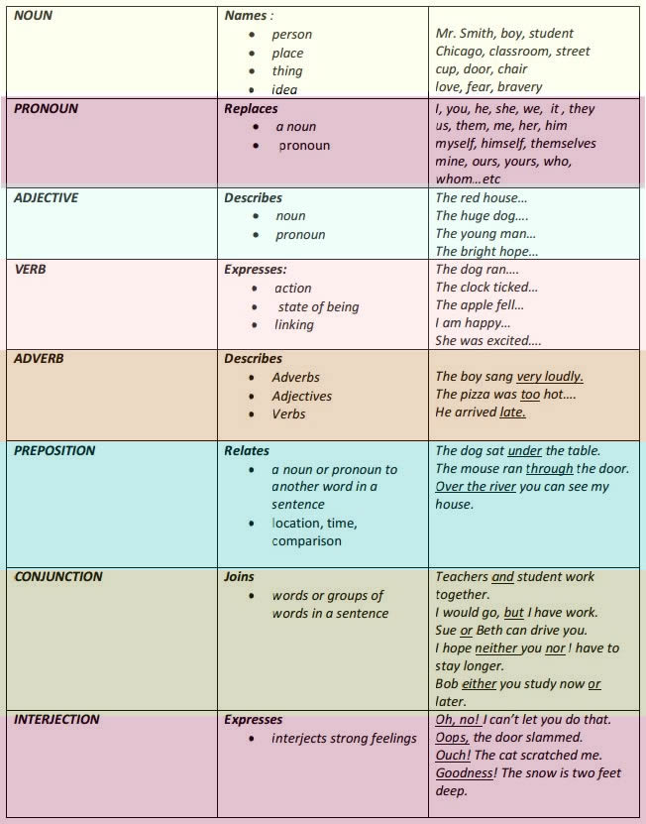

What does each of the parts of speech do?

Parts speech | Function or job
Verb | action or state
Noun | are a thing or person
Adjective | describes a noun
Adverb | describes a verb, adjective or adverb
Pronoun | replaces a noun
Preposition | links a noun to another word
Conjunction | joins clauses or sentences or words
Interjection | short exclamation, sometimes inserted into a sentence

