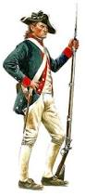
Revolting Times!
Directions:
You will create a newspaper that highlights several important aspects of the American Revolution. Your stories will be based on facts from researching this time period. As a team, you must complete the following:
1. You must choose a point of view from which to write the articles – either Loyalist or Patriot.

2. Create a title for your ‘newspaper’. Your names will be in smaller print underneath this as editor.

3. One article focusing on a specific battle of the Revolutionary War. Here are some ideas: Lexington, Concord, Fort Ticonderoga, Bunker Hill, Long Island, Trenton, Princeton, Brandywine, Saratoga, Monmouth, Savannah, Yorktown, King’s Mountain
OR
4. One article focusing on a famous person from that time period. Here are some ideas: George Washington, Benedict Arnold, Nathaniel Greene, Marquis De Lafayette, Baron von Steuben, Joseph Martin, Charles Cornwallis, Ethan Allen, George Clark, Benjamin Franklin, John Burgoyne, King George III, Thomas Jefferson, Thomas Paine, Abigail Adams, Edward Braddock, Samuel Adams, John Paul Jones, Baron De Kalb, Alex Hamilton, Molly Hays McCauley, Deborah Sampson, Patience Wright

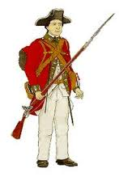
5. One article focusing on a topic of your choice from the following: Women, African Americans, Involvement of Foreign countries, Casualties and Cost of the War, Treaty of Paris (from Revolution), Music, Colonial Flags, Espionage, Food, Diseases, Medicine

5. One advertisement depicting a product or service that would be needed during the Revolutionary War.

6. Before you begin: decide which battle, which person, and which product/service you will write about.

7. Works cited page

8. Read over your rubric as you work to ensure your best work.

Newspaper Criteria

Check each item as you complete it:
____Title creatively and attractively includes your name, name of newspaper, date of publication (revolutionary times…not present day)
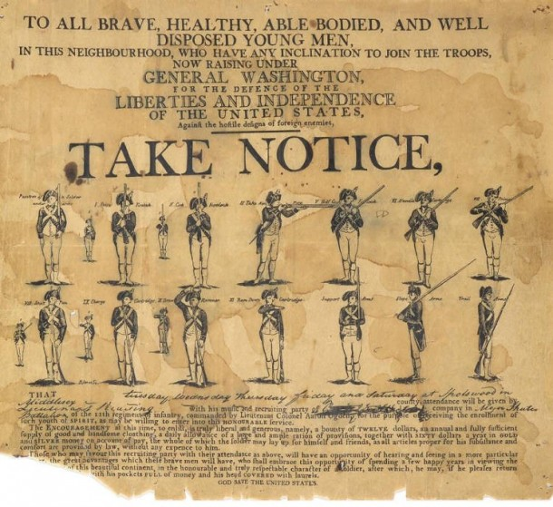
Article about a battle:
___ NAME of the battle
___ DATE it happened
___ Report of the battle – what happened?
___ Location
___ Number of British involved
___ Number of Americans involved
___ One illustration of the battle

Article about a famous person during Revolutionary Times includes:
___ In what ways was the person involved in the war?
___ What important things did this person accomplish?
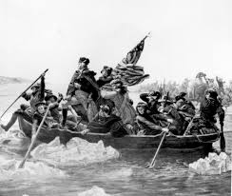
___ Illustration of the person.
Free Option Choice:
___ In what ways did this item/group of people affect the war?
___ What important things did this item/group accomplish?
___ Illustration of the item/group.

Advertisement includes:
___ Neat - organized - colorful drawing
___ Realistic description of product or service

Works Cited page:
___ Minimum of 3 sources
___ Minimum of 1 primary source
___ Minimum of 1 print source

BATTLE Which battle? Where? When? What happened? How did it happen? What’s the illustration? | FAMOUS PERSON  Who is it?  Loyalist or Patriot?  What did they do? Why are they famous?
ADVERTISEMENT  What are you selling - a product or service?  What’s the price? Is there a deal?  What’s the illustration? | FREE CHOICE OPTION  What is the topic? How did it contribute to or affect the war?

Revolting Times Newspaper Rubric

Title creatively and attractively includes your names, name of newspaper, date of publication (revolutionary times…not present day)  Article about a battle includes:  - Important event that led to battle  - Report of the battle  - NAME of the battle  - DATE it happened  - Location  - Number of British involved  - Number of Americans involved  - One illustration of the battle  Article about famous person during Revolutionary Times includes:  - In what ways was the person involved in the war?  - What important things did this person accomplish?  - Illustration of the person  Free Choice Option:  - What is the topic?  - How did it contribute to or affect the war?  Advertisement includes:  - Neat, organized colorful drawing  - Realistic description of product or service  Works Cited page includes:  - Minimum of 3 sources  - Minimum of 1 primary source  - Minimum of 1 print source | 5 POINTS  20 POINTS  10 POINTS  10 POINTS  5 POINTS  5 POINTS

